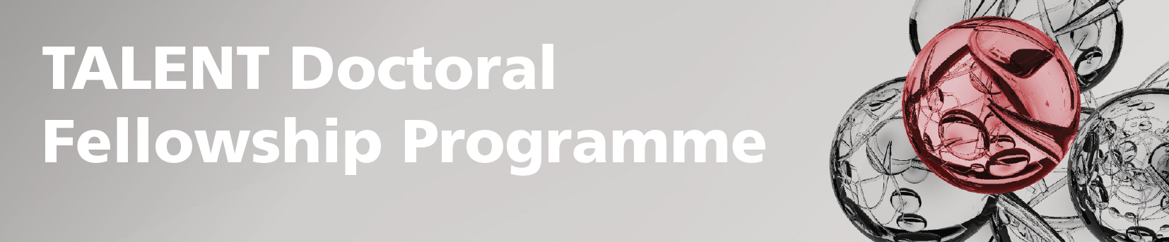

Personal Career Development Plan

Project Information
Name of fellow | Enter name
Orcid (https://orcid.org/) | Enter ID
SCIENCE department | Choose a department
Name of main supervisor | Enter name
Title of PhD project | Enter title
Acronym | Enter acronym
Employment start date | Enter date
Employment end date | Enter date
Date of the PCDP | Enter date

Introduction
Each TALENT PhD student has a main supervisor, who is an associate professor at UCPH/SCIENCE. The supervisor provides guidance on scientific matters in his/her discipline, incl. challenging the PhD student’s academic work to inspire excellence in research, and counselling on career perspectives.

To help the TALENT PhD students build and strengthen their careers, each fellow, main supervisor and any relevant co-supervisor are obliged to draw up a personal career development plan (PCDP) in collaboration. The plan should be based on the fellow’s personal preferences and the supervisor’s knowledge of the possibilities at UCPH/SCIENCE.

The PCDP is required within three months of the project start and is made to ensure that all parties are fully aware of the career development objectives of the project and that there is a clear plan for their achievement. The main supervisor and student must sign the PCDP, which they will review bi-annually or more often, if required, to make sure that new opportunities that emerge during the project are taken account for.

The fellow is to upload the signed PCDP in PhD Planner under the PhD plan (there is a box in this section for uploading documents).

How to go about drawing up the PCDP:
- The plan is supposed to be 1-3 pages.
- Please adhere to the structure below.
- You may include additional points, which you find relevant.

Expected accomplishments
State specific and realistic goals and sub-goals with detailed plans and deadlines.

Project objectives:
- Expected milestones.
- Research results, anticipated publications, conferences, workshop attendance, seminar presentations and courses (ECTS). For available courses at UCPH/SCIENCE, please see here.
- Research skills and techniques, training in specific areas or technical expertise.
- Research management (incl. IP), funding applications planned.
- Possibilities of short-term secondment in industry or academia with the aim, e.g. to learn a new skill.
- Teaching and communication skills.
- Impact on career, career-promoting networks, integration into UCPH/SCIENCE and Denmark.

Personal short-term goals (1-3 years) and how to achieve them, e.g. courses, publications, conferences, personal development, contact with and participation in events hosted by International Staff Mobility (ISM) at UCPH (expand both scientific and social networks), preparation for the period following the TALENT PhD fellowship at SCIENCE, mobility etc.
Personal long-term goals (3-5 years) and how to achieve them, e.g. future employment in academia, public or private sector, publications, conferences, personal development, mobility etc.

List of publications and other dissemination activities stemming from the work performed during the fellowship, incl. the Digital Object Identifier number (DOI). (For the reviews of the PCDP.)

Date & signature of the fellow: ______________________________

Date & signature of the main supervisor: ______________________________

ALL your results and outputs must acknowledge the TALENT funding by displaying the European Union emblem and including the following statement:

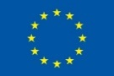
This project has received funding from the European Union’s Horizon 2020 research and innovation programme under the Marie Skłodowska-Curie grant agreement No 801199

Read more about acknowledgement of EU funding here.

Furthermore, please observe the Open Access (OA) rules:
Publications must be made available OA (either golden open access or green open access). If green OA is chosen, for publications in the natural sciences and life sciences an embargo of max. 6 months is accepted. For social sciences and humanities 12 months is accepted. These rules refer to post-prints of peer reviewed articles.

If you wish to publish using the green OA option in a journal that has longer embargo periods than the rules permit, please contact the TALENT secretariat (SCIENCE Research & Innovation) at talent@science.ku.dk to see if the TALENT EU project officer is willing to accept a longer embargo period. We have seen some flexibility, with a 12 month embargo for natural and life science publications approved in certain circumstances, but this must be done in advance of the publication being published and cannot be taken for granted.

Please observe that the EU Commission is increasingly focusing on compliance in terms of publications emerging from EU funded projects. This is in relation to both acknowledgement of EU funding and OA. Please note that the Commission is legally able to reduce the size of a grant if the OA rules are not adhered to.

The TALENT secretariat will contact each fellow every six months regarding publications, as information in this regard is required for the reporting to the EU Commission.

